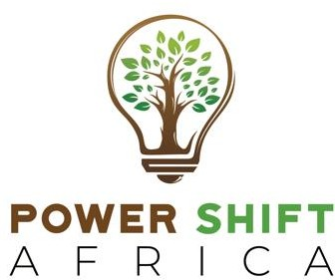

# Wednesday, November 6, 2024

POWER SHIFT AFRICA STATEMENT ON US ELECTION RESULTS

# A Moment of Truth for Climate Justice

The gavel has fallen on the US elections.

The uncertainty of this election has disrupted progress in climate negotiations for months. At the Bonn session in June developed countries were too cautious to pledge any money for climate finance.

Throughout this year, the Global North has not shown any goodwill that truly inspires confidence in the climate process.

This puts COP29 in great limbo.

The victory of President-elect Donald Trump puts increased scrutiny on this COP. Baku is expected to and must deliver a clear plan for climate finance for the vulnerable communities of the world.

Only an ambitious new finance goal in Baku will protect the current climate momentum from a potentially disastrous Trump presidency.

Climate action is urgent. Victims of climate catastrophes in the Global South need life- saving support. The energy transition needs to be funded.

The world has dealt with a Trump presidency that included the withdrawal of the US from the Paris Agreement. His return could see a second exit from the agreement by America and the cancellation of its climate commitments.

This is a moment of profound apprehension in global climate diplomacy. But not one to cower from in dread.

Rather, it is a moment that calls on us all to exercise our moral duty to protect the planet and millions of vulnerable people from the consequences of self-defeating climate denial and inaction.

Previously, we witnessed a forceful mobilisation of regional and global actors stepping up to create a robust movement for climate action and to accelerate the transition away from dangerous fossil fuels.

It worked then. It can work again.

Our world needs an even stronger coalition of the sensible to counter the dangerous ignorance and potential blunders of the incoming president.

Today, the economics of clean, renewable energy are so obvious that not even Trump can hold back progress. Climate science is undeniably clear.

# Lest we forget…

Under the Biden administration, the US has remained the world’s biggest fossil fuel producer and consumer. America has also consistently blocked progress at international talks on climate finance — while pledging insignificant resources to address climate impacts.

We cannot lose hope on our planet. Or spare any efforts to protect it. Even when our efforts are dented, we must rise again to fight to save our home and preserve life on Earth.

We must advocate for climate justice and transformative change in our world even more fiercely and relentlessly. The test of our resolve has never been bigger.

This is the moment.

# Mohamed Adow, Founder and Director Power Shift Africa